A church that has clergy and lay leaders who innovate, envision and motivate people
  - A bible study from Revd Simon Taylor (Rector) and Revd Catherine McBride (Associate Minister) from Busbridge & Hambledon Church, Guildford diocese.

You must be dreaming!
Key points of this Bible study:
- The importance for Christians and churches of visualising future possibilities, new ideas and the motivation for this?
- Seeing how these are expressed in Scripture
- This is about a culture and mind-set of envisioned possibilities rather than simply doing some new things
How to approach this study
The Bible study has been designed so that it can be used in three ways.
Half day: The whole study white, pink and blue sections
Hour and a half: Most of the study white and pink sections
Twenty minutes: Part of the study white sections
The dream of possibilities!
How do you read the statement ‘You must be dreaming!’? Is it something you would say to someone who has just proposed the most hare-brained idea you could have thought of? What could they possibly be thinking!? Or is it the heart-felt plea for some out-of-the-box thinking; that we must dream?
Churches can become stuck in the same patterns of thinking and doing things; whereas, God’s exhortation is that we are the Church which must dream of his possibilities. Dreaming of the possibilities of God involves envisioning a landscape which is not yet visible, innovating and motivating to achieve it.

Digging Deeper: Three Big Attributes of a faith in the possibilities of God
Innovate has a Latin root to it meaning ‘into the new’.
The Hebrew word for motivate means ‘spur’ such as being spurred on to something. At its core it is about a reason for doing something.
Envision is similar to the word vision. It is about an action of imagining a future possibility. Envisioning could be described as putting reality around a dream.
We might call them Three Big Attributes of a faith in the possibilities of God.
How do these descriptions fit your understanding of these attributes?
To some people the language of visualising future possibilities, new ideas and the motivation for this is positive and exciting, but to others it provokes negative reaction. All three are attributes are about an attitude that sees possibilities and trying things in new ways.
What examples can you think of where your church may have become ‘stuck’ in its way of thinking or doing things?
What examples do you have of where your church has done something new?
In each case, what do you think were the reasons behind what happened?

The God who dreams big!
Read Genesis 1:1-5; Genesis 1:26-28
What can we learn about the nature and character of God from this passage in terms visualising future possibilities, new ideas and the motivation for this?
What is God’s motivation for His actions in the Creation?
What does God envision is going to be created as the Creation account unfolds?
What is new in what God does here?
What does Genesis tell us about our own ability to be creative and innovate and how we should use this? What should motivate our creativity?
Genesis 1:27 informs us that we are created in the image of God. What do you think are the implications for us of this in relation to the Three Big Attributes?

“Creativity is worship insofar as it is, at its essence, a response…In the call to be creative, a call that goes out to all God’s children, we sense the call to listen to him and, in childlike naiveté, to imitate our father by creating works that will magnify his praise”
Christian Innovation Descending Into the Abyss of Light by Gary W. Oster
Aesthetics, 276-281.

Digging deeper: What’s in a Name?
There are many names for different aspects of God in the Old Testament. One name is Yatsar, God the maker of Heaven and Earth. In Genesis God is described as God the maker.
What does this tell you about God in relation to the attributes of visualising future possibilities, new ideas and the motivation for this?

James’ Story: The Path
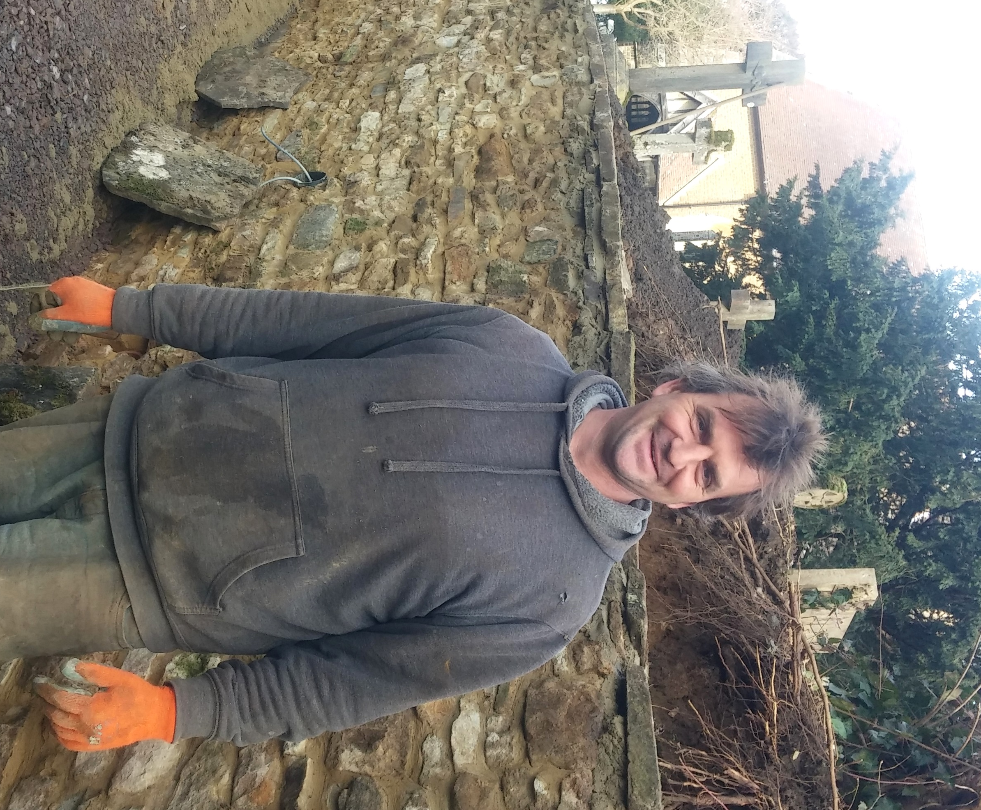
James is a builder. He builds things. That is what he does, day in and day out. Landscaping, fences, walls, buildings. He builds. His local church engaged him to build a new path through the churchyard.
The church building was on a bit of a hill, only approachable by steps. There had been talk of creating a path in the past but it had come to nothing. The local community had got used to the same old route of going around the hill, and the church building. The church had become a faded irrelevance and a bit of a carbuncle on the hill. It eventually became clear to everyone that there really was a problem. Toddlers, buggies, wheelchairs, the elderly; everyone found access difficult. The church brought James in.
It was to be a path to the church and past the church to the local school; it was a path for everyone. It had warm, yellowed with age stone sides and beautiful cobbled edgings to it. It was a path but it was more than a path. The path was about bringing people towards the building and to a new idea that the church was accessible, relevant and welcomed them.
As James built, something began to happen. Families stopped and talked to him. None of them called him a builder. They referred to him as a “maker” of a beautiful creation, a “craftsman” of a work of art. James began to recognise that he was making something important and of greater value than he may have imagined when he accepted the job of path-builder. He was a maker of something new, something which required imagination to see its possibilities.
As the path neared completion people began to ask questions. If there was now a path to the church, could the church offer a coffee-drop in for those walking towards it? People began to ask why the church would do something like lay a path for people who had nothing to do with the church. It led to interest in why Christians do things for the community. It led to people joining the church and being transformed by coming to faith in Christ.
It all began with an idea, a creator of new things called James and a path. The path had been talked about for many years.
What was needed in the church for the talk to become an innovation that actually happened?
How does the story reflect that which we learnt of the God who dreams big?
What does James’ story reveal to us about what can happen when new things are envisioned?
To what extent can you identify with James the creator of the path and who we are to be as Christians?

The message of Scripture is that while we are creative, it is God who is Creator. When we create new things or change old things we do so because this is part of who God has created us to be. “God awaits man‘s creative act, which is the response to the creative act of God” Discuss this statement.
Nicolas Berdyaev, Dream and Reality: An Essay in Autobiography, trans. Katherine Lampert (Grand Rapids, MI: Eerdmans, 2004), 277; Thiessen, Theological

Digging Deeper: Path to Christ
James’ story is being replicated up and down the country every day of the week in churches small and large. The story may not involve an actual path, but it does involve people who begin to see the possibilities of God. When we see the possibilities we begin to form paths for people to come to faith in Christ.
What are some of the possible ‘paths’ that you might create in your church setting?
The Dream is Big!
Read Acts 11.1-24

What’s going on in Acts 11?
In Acts 10 Peter has a vision which challenges his understanding of what food he is permitted to eat and what he should consider ‘impure or unclean’. It shakes him to the core. He is still trying to work in the old model but God had made all things new in Christ. Immediately after his vision he is asked to go to the house of the Gentile centurion, Cornelius. His usual response would have been, ‘You must be dreaming!’ A Jew would not have associated with a Gentile and certainly not entered their house.
The vision helps him realise that God clearly has other ideas. It isn’t Peter coming up with a new idea of his own. It is God giving Peter a clear understanding of the true extent of the purpose of Christ’s death and resurrection and this is to be made available to everyone.
Peter goes to Cornelius’ home, tells him about Jesus and is amazed when the Holy Spirit comes upon all those who are listening. In response, he baptises Cornelius and his household; however, when the Jewish believers in Jerusalem hear about what Peter has done they are less than happy and he is has to explain his actions.
Later in Acts 11 we hear of persecution of the followers of Jesus in the same breathe as we hear of the growth of the Church. Pressure and possibilities seem to go hand in hand.

What is critical about the fact that Peter’s vision happens when he is praying? What do we learn from this about how God might envision us?
Why do you think the believers in Jerusalem were critical of Peter’s actions? What motivated this response? How do you relate to some of those motives?
What does Peter learn about God through his vision? How did this impact on his actions?
Which do you think influenced Peter’s change of heart the most: his vision, or his experience of what God did at Cornelius’s house?

Read Acts 15:15-21
What guiding principles do we get from how Paul responds to the Council at Jerusalem which can help us in deciding how, or if, to implement a new idea?
Which parts of the Bible would you take as your guiding principles to measure new ideas against?

Guiding principles If you are looking for some passages to look at in relation to guiding principles then here are a few examples. What do they teach us about guiding principles for visualising future possibilities, new ideas and the motivation for this?
Luke 10:27 He answered, “‘Love the Lord your God with all your heart and with all your soul and with all your strength and with all your mind’; and, ‘Love your neighbour as yourself.’”
Romans 12:2 Do not conform to the pattern of this world, but be transformed by the renewing of your mind. Then you will be able to test and approve what God’s will is—his good, pleasing and perfect will.
2 Tim 1:13 What you heard from me, keep as the pattern of sound teaching, with faith and love in Christ Jesus.

Digging Deeper: Checking it Out
Imagine your local car showroom was bought by new owners. Suppose they changed the display from cars to farm machinery because they’d heard that tractors give better profit than cars. They might tell everyone they were still great at car sales but you’d probably think twice about going there for your next car. You would want to check it out first.
Peter engaged in a radical, risky and personally challenging path. The response of the believers was to check it out. They wanted to check his motives, actions and evidence. When stories of Greeks turning to Christ reached the Apostles they sent Barnabas to check it out. He looked for evidence of God at work (Acts 11). In Acts 15 when Paul explains what he has been doing, James looks to Scripture for evidence.
What are the checks that you would put in place to test the motives for any new endeavour?
Awakening the dream
We have explored:
Here’s how the founder of the Roman Catholic Jesuit Order put it:
“He who goes about to reform the world must begin with himself, or he loses his labour…. Go forth and set the world on fire.” Ignatius of Loyola
What is your response to this quote and the cycle of visualising possibilities, new ideas and the motivation for this?
Describe a time when you had an idea. What was it? What sparked it? What happened to your idea; did it come to something, develop, or did it die?
How did your Christian faith impact on the way the idea developed?
Thomas Eddison’s view of the importance of envisioning, innovating and motivating was:
“to invent, you need a good imagination and a pile of junk”
(Thomas Eddison, inventor of the lightbulb cited in Hargadon and Sutton p160, 2000)
God can work with whatever and whoever is brought to him for his service, even five small loaves and two fishes. What one thing will you do now as a church to allow ideas to grow into visualising future possibilities, new ideas and the motivation for this?

