Marriage Registration FAQs

Training
I can’t access the training videos. What should I do?
Please send as much detail as you can (the problem you’re encountering, how regularly it occurs, the web browser you are using and when you are trying to get access) to the email address given on the GRO instructions for accessing the training.
Can I share the training with others – e.g. my parish administrator? Who should the training be shared with if a parish or benefice is in vacancy?
You can share the training with your parish administrator, and it can also be shared with church wardens if the parish or benefice is in vacancy. Please do not post the details on any online message boards / shared platforms.
What can we do if there are clergy / PTOs in our diocese who do not use a computer?
It is fine for the PowerPoint training presentation to be printed and sent out to colleagues who cannot access this electronically. The same applies to any clergy newsletters that the GRO have published on GOV.UK
https://www.gov.uk/search/all?keywords=clergy+newsletters&order=relevance
GRO have also traditionally made a publication available on GOV.UK called “Guidance for the Clergy”. The current version is available in the same link as the newsletters above. It will be replaced with the updated version ahead of implementation.
Is a BSL interpreted or subtitled version of the training available?
The GRO have provided PowerPoints with the speaker’s notes on the LRSA website as an alternative and more accessible version of the videos.
The Marriage Document
What is the difference between a Marriage Document and a Marriage Schedule?
The Marriage Document is the preliminary document prepared by the clergy (or their administrator) for couples to sign on the wedding day at the point in the service when they would have signed the Marriage Register. The Marriage Document replaces the signing of the Register. Church Marriage Registers will therefore close after May 4th 2021.
The Marriage Document will contain all the information that will be entered into the Marriage Register – this will no longer be in the church. At the marriage ceremony it would be signed by the couple, their witnesses and the person(s) officiating at the marriage and then delivered within 21 days by the officiant (or by someone else on their behalf) to the register office for the marriage to be registered in an electronic register. This new online register is maintained by the Registrar General.
The Marriage Schedule is different. This is issued by the Superintendent Registrar for those couples who need to have civil preliminaries (formerly called a Superintendent Registrar’s Certificate). The Marriage Schedule is the authority on which the marriage can proceed in the church. It will be signed and witnessed in the same way as the Marriage Document during the service, and will need to be returned by the minister in the same way as the Marriage Document
At what point in the marriage service is the Marriage Document signed?

The Marriage Document is signed at the same point in the marriage service when the Marriage Register would have been signed.

Am I obliged to record the bride’s and groom’s mothers’ details – or is it up to the couple?
It is up to the bride and groom to decide which parents (up to four per person) are included on the Marriage Document and in which order the names appear – the details will then appear on the electronic register / marriage certificate in the order given on the Marriage Document.
How do we get hold of the Marriage Document to be used during the ceremony?
There is a type-and-print document which is available on the LRSA website for clergy and parish administrators to download and save on their own PCs. You should have received details for this through your Diocesan Secretary or Archdeacon.
You can print the Marriage Document off as a manual hard copy as a back-up if you wish but there will also soon be ready-printed versions available to order.
In addition, the free online admin tool provided by the Church of England, www.lifeeventsdiary.org, will be updated to enable printing of the Marriage Document for weddings happening after 4th May.
How should we return the Marriage Document after the wedding has taken place? Do I need to make an appointment at the local register office?
No, but clergy will be required to ensure the Marriage Document goes to the local register office – usually this will be by post, or they may deliver it in person if they choose. The reasoning behind this is that clergy will be in touch with the same local register office for all weddings conducted in their church, whereas a couple may not know where the local office is and may be living far away once the wedding is over.
What is the situation should the one and only copy of the signed Marriage Document get lost or damaged between being signed at the ceremony and getting registered?
We hope that this will be a rare occurrence, but if a Marriage Document is lost or destroyed then the Marriage Act (section 53E) will allow the Registrar General to direct, in writing, the relevant church official to
- reproduce the Marriage Document, and
- arrange for the reproduction to be signed again by the original signatories, so far as is reasonably practicable.

The GRO also understand that in some circumstances, it might not be possible for all the original signatories to sign the reproduced Marriage Document, and where this is the case, the relevant church official should explain why, for example a witness may have returned to live abroad and it is not practicable for them to sign again.
Once the registrar is satisfied that, so far as is reasonably practicable, the reproduced Marriage Document has been signed by the original signatories, the reproduction is to be treated as the signed Marriage Document for all purposes under the Act.
For couples marrying by Archbishop’s Licence in a College Chapel, will the officiant produce the Marriage Document, or will it be the responsibility of the incumbent of the parish in which the chapel is located?
It will be the responsibility of the person conducting the wedding.
Do I still do the banns?
Yes. The marriage registration process has no bearing on the banns system and you should arrange for these to be done in the usual way. All the same information for banns is collected, just as before.

When a different priest other than the incumbent of the marrying church takes a wedding: what goes in the top box, where it says ‘issued by’? Is it the vicar and their own parish/role, or is it the administrator who has prepared the form?

In the box at the top the parish where the marriage is taking place, along with the name of the church, is always entered, regardless of who takes the wedding, as it will be that church/parish that will be entered in the register.

So if you were issuing the document yourself (as a member of the clergy from a different parish) it would say:

Marriage Document issued by: Revd (your first name and last name) in the parish of (church and parish where the wedding is taking place).

Church Register of Marriage Services
How is the Register of Marriage Services different from the old Marriage Register?
The civil registrar is responsible for registering all marriages that take place in the district. Marriages will no longer be registered in church on the wedding day, so there will no longer be a marriage register in church. However, the view was taken at the outset of the Church’s discussion with the General Register Office on the proposed reforms that if civil registers were to be removed from churches, there should still be a requirement for a formal church record to be made of marriages that have taken place in a church. This was largely for pastoral reasons and so that subsequent generations could find a record of their parents’ / grandparents’ marriage at a particular church. The new ‘Register of Marriages’ is exactly that – a record that the event took place, much like the baptism register.
Will each church which is licensed for marriage services be legally required to obtain a Register of Marriage Services from Church House Publishing?
It will be a legal requirement under Regulations made under the Marriage Act 1949 for the cleric who solemnizes a marriage to record certain particulars in a “Register of Marriage Services”. The Regulations will say that the Register of Marriage Services is to be kept in the form of a book in the church or chapel where marriages take place. A parish could print and bind its own book if it wished, provided it enabled the particulars required by the Regulations to be recorded. The register available from Church House Publishing is specifically designed to meet the new legal requirement. There is no need to obtain a book until the first marriage takes place under the new registration regime.
Why can’t we just have one register per benefice?
All existing statutory church registers relate to a particular church or chapel – baptism registers, burial registers, banns registers. It would be confusing – and not simplify matters – if the Register of Marriage Services was kept on a different basis. There are no other records that are kept by benefice.
Are there any GDPR concerns around the new Register of Marriage Services?
The new Registers are in fact required by law to be completed and kept. The relevant legal requirements will be contained in secondary legislation that is shortly due to be laid before Parliament by the Registrar General. The lawful basis for processing the data in the register will accordingly be legal obligation.
Will Registers of Marriage Services definitely arrive by May 4th – and what should we do if ours is delayed?
The Register of Marriage Services is available to buy from Church House Publishing https://www.chpublishing.co.uk/books/9780715111796/register-of-marriage-services. There is high demand for the Register of Marriage Services at present, so in the event of a register not being delivered before a wedding (or weddings) takes place, the officiant will be allowed to enter the details of a wedding after it has already taken place. Please note that all the details can be completed after the wedding and no-one is required to sign the Register of Marriage Services.
What will the Register of Marriage Services look like? What information will I need to fill in?
This is a sample of a page from the Register of Marriage Services from CHP:
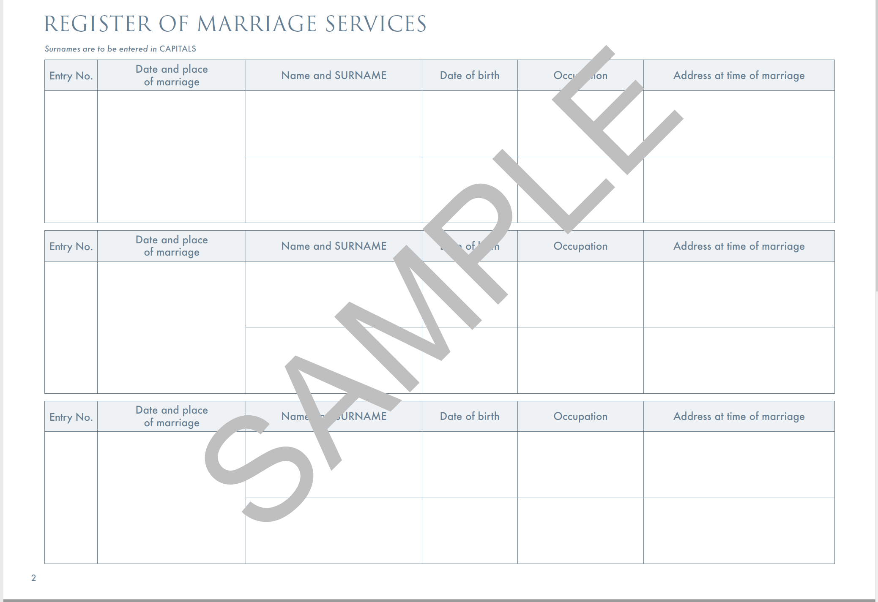
The design is copyright © The Archbishops’ Council and each numbered entry will contain:
The date and place of the marriage
The bride’s name and surname, date of birth, occupation and address at time of marriage
The groom’s name and surname, date of birth, occupation and address at time of marriage
Will it need to be signed by the couple and their witnesses?
No. The officiant, the couple and their witnesses will sign the Marriage Document. The Register of Marriage Services is similar to the Baptism Register – it is simply a record of the service having taken place. There is no need for the couple or the witnesses to sign it and it can be completed after the wedding day.

There is a Liberty church in my patch that stands outside of the usual diocesan structures. Now that Marriage Registers are no longer held in churches, does the Liberty use its own Register of Marriage Services, and therefore use its own numbering system to put on the Marriage Document, or are marriages that take place there still recorded in the Register of Marriage Services of the parish church?

The new registers are only for churches and chapels in which banns can be published. They are not for buildings in which marriages may take place only by Special licence, so there is no legislative provision for a marriage in this place to be recorded in a register of marriage services. The chapel could have a book to record services, but that would be entirely voluntary and of no legal consequence. Marriages in this chapel should not be included in the register of marriage services in the parish church.
Reconciling records on May 4th and afterwards
What should we do with the existing registers in our churches when the change-over has taken place? How do we close the register?
Your local register office will have supplied you with labels stating the following:- “Due to the introduction of the Civil Partnerships, Marriages and Deaths (Registration etc) Act on 4 May 2021, this marriage register book has been closed.” On 4 May, in the page immediately after the last completed entry in your current duplicate marriage registers, you should draw a diagonal line in registration ink through every unused entry and then stick the label on the front of both of the open duplicate registers.
The register should then be delivered to/collected by your local registration service, along with your other registration stock in accordance with your existing arrangements, or by the method referenced below.
Return of Registration Stock (Registers, Quarterly Copies/Nil Returns and Certificates)
There will already be existing arrangements in place with your local register office for the delivery/collection of quarterly/nil returns and filled marriage registers. The Registrar General would suggest that you continue to use such arrangements. However, please be aware that due to current COVID restrictions these arrangements may have changed. Please contact your local register office to check their current arrangements before returning any stock.
Please note that when returning secure stock such as certificates, a secure method of delivery should be used and for that reason, delivery in person may be the most suitable option. You may wish to discuss this further with your local office.
The duplicate register will be retained by the Superintendent Registrar with the records of his/her office. The closed duplicate register retained at the church should be kept in the church safe or in archival or diocesan custody as deemed appropriate.
Do we still have to make quarterly returns?
You will need to submit a quarterly return (or nil return) for the period including 3rd May 2021. After this time there is no need to submit a quarterly return.

How will our local register office keep in touch and remind us to submit completed Marriage Documents / Schedules?
The changes to the marriage registration process do not interfere with ecclesiastical preliminaries and there is no duty on members of the clergy to give advance notification of any impending marriage to registration officials.
There is a duty on the member of the clergy to ensure that the signed Marriage Document is delivered to a registrar for their district within 21 days, however the responsibility to ensure that all marriages are registered lies with the registration service. Therefore, a registration official may contact a member of the clergy to establish if a Marriage Document they have received is authentic or to establish that the details of a marriage has been duly registered, these arrangements will be decided locally.
General
Have the fees tables been updated to show that we are no longer charging for marriage certificates after May 4th?
Yes. All the fees tables on the CofE website, and the popular editable download from Church Support Hub Wedding fees form 2021 | Church Support Hub have been updated. For weddings taking place after May 4th, churches should no longer collect a fee for the Marriage Certificate as this will be created by the register office after the marriage has been recorded onto the electronic register.
How can the couple get their Marriage Certificate?
They will contact the register office or the General Register Office directly to purchase a certificate. The registration by the register office will be made by the 7th day after the Marriage Document is received at the register office. A certificate will be available after this time, though local arrangements for issuing of certificates will also be factored into the timescale.
Some couples may not know which is the relevant register office, so someone from the church could tell them where that is, but they can also find out at any time by putting the marrying church’s postcode into the search box on this site: Find a register office - GOV.UK (www.gov.uk)
Is there anything that we can give to the couple on their wedding day?
Yes. There is a new wedding congratulations keepsake, available to order from Church House Publishing: (https://www.chpublishing.co.uk/books/9780715111833/wedding-celebration-keepsake-card-pack-of-10 ).
Although it has no legal standing, it is a beautiful memento of a couple’s wedding day for them to keep. A black-and-white simplified version is also available for you to download and print from the Church Support Hub.

The Life Events team will keep you informed of any further updates via its newsletter. You can sign up for this by visiting the Church Support Hub and clicking the yellow tab, bottom right of the home page.

